**Only the source code has to be uploaded the site report has to go in the web**

**Web assignment 1**

**Name** Hamza Younis Raja

**Id** 19431130

**Introduction**

The purpose of this assignment is to assess your ability to create a web page using HTML and CSS andmanage your code using Git/GitHub. You are tasked with developing a portfolio with at least five pages

**This is link for my Git-Hub repository**

<https://github.com/hamzaraja333/WEB-ASSIGNMENT.git>

**PROGRESS MADE FROM** **(From 12-11-2020 To 1-7-2021)**

1. **INDEX.HTML**

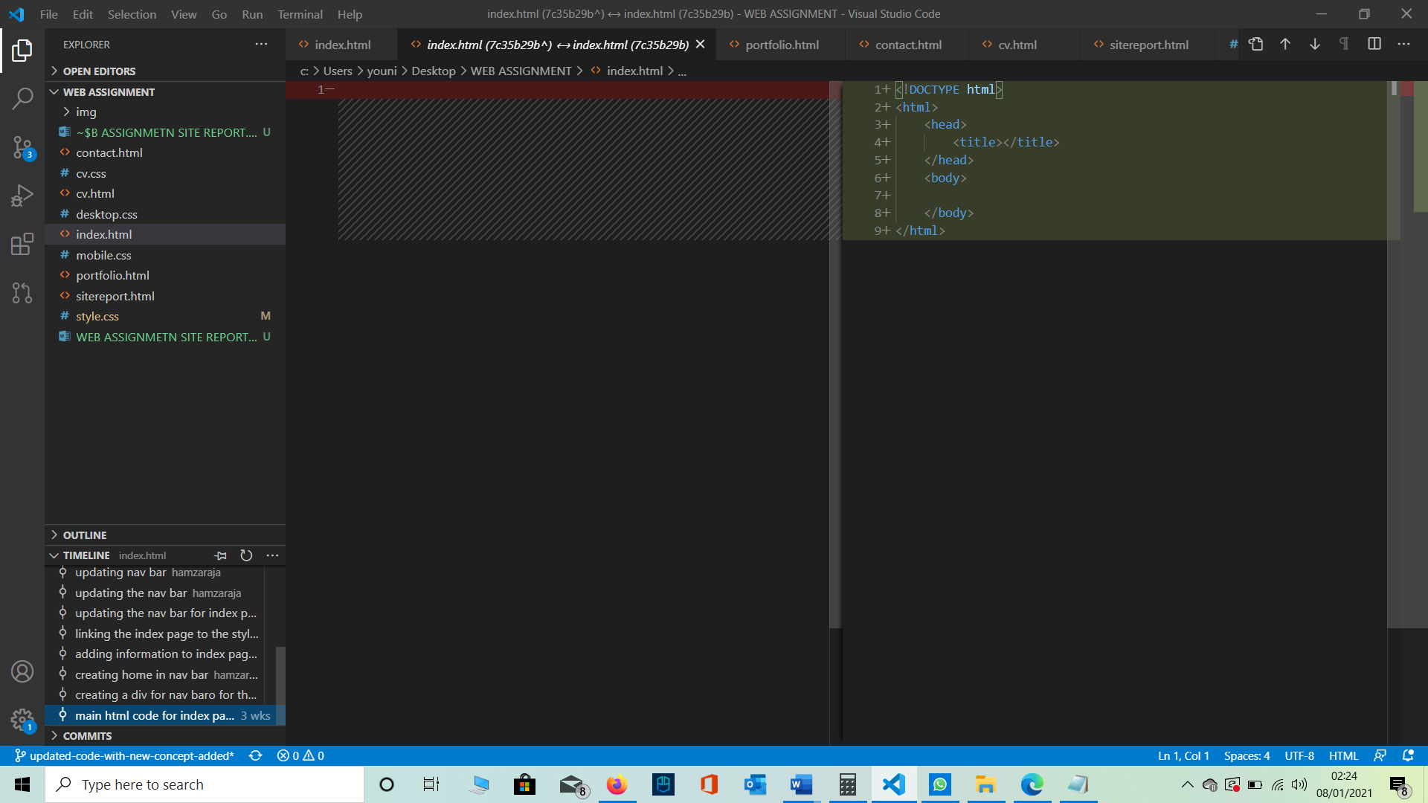

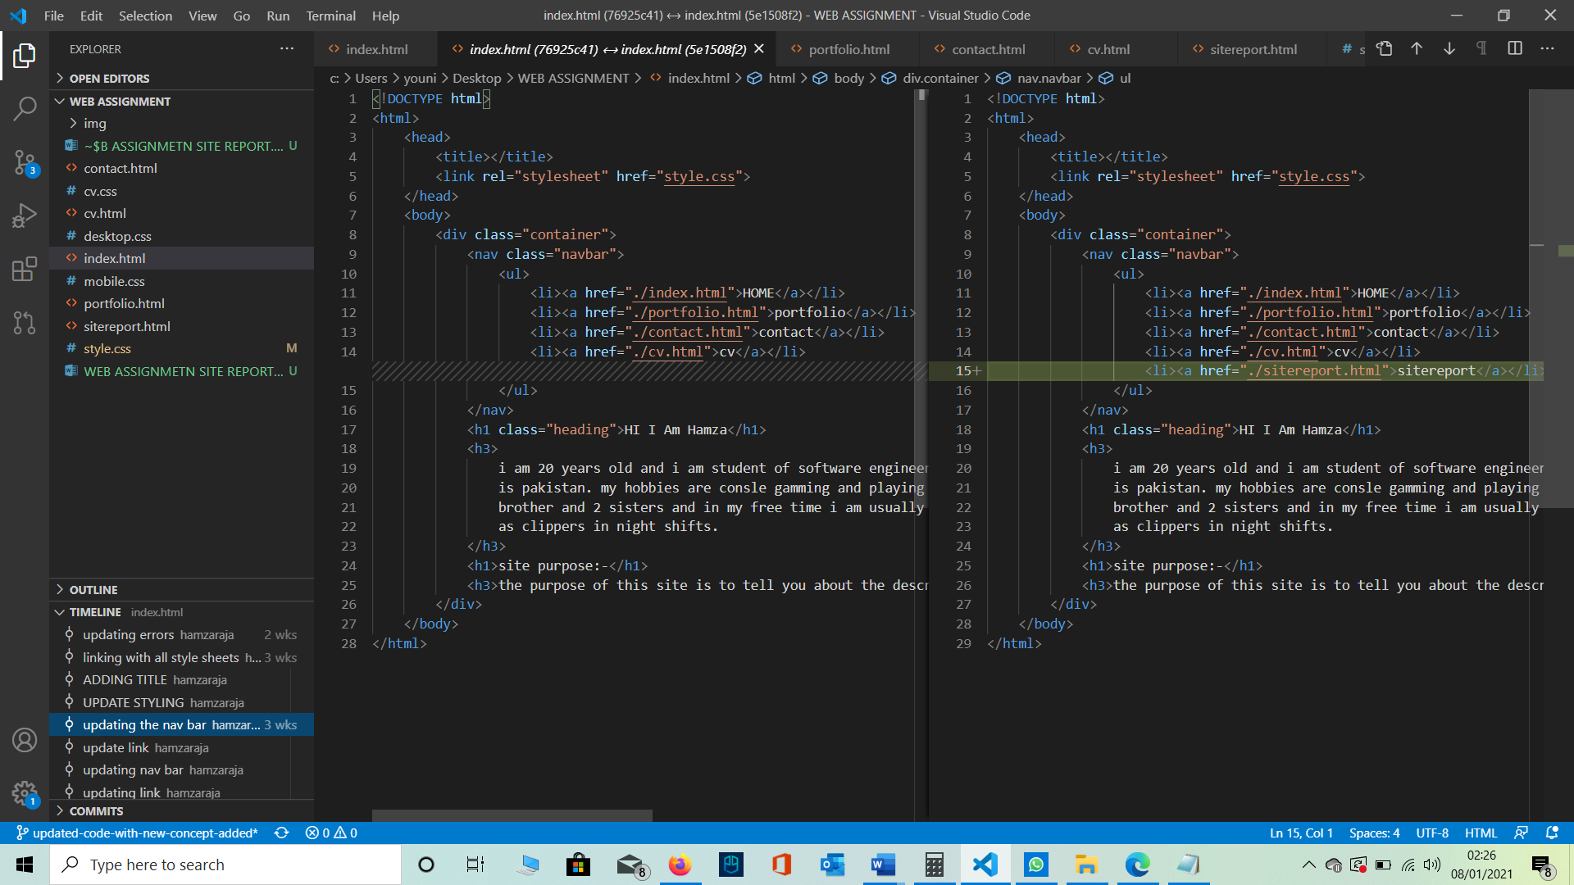

1. **PORTFOLIO.HTML**

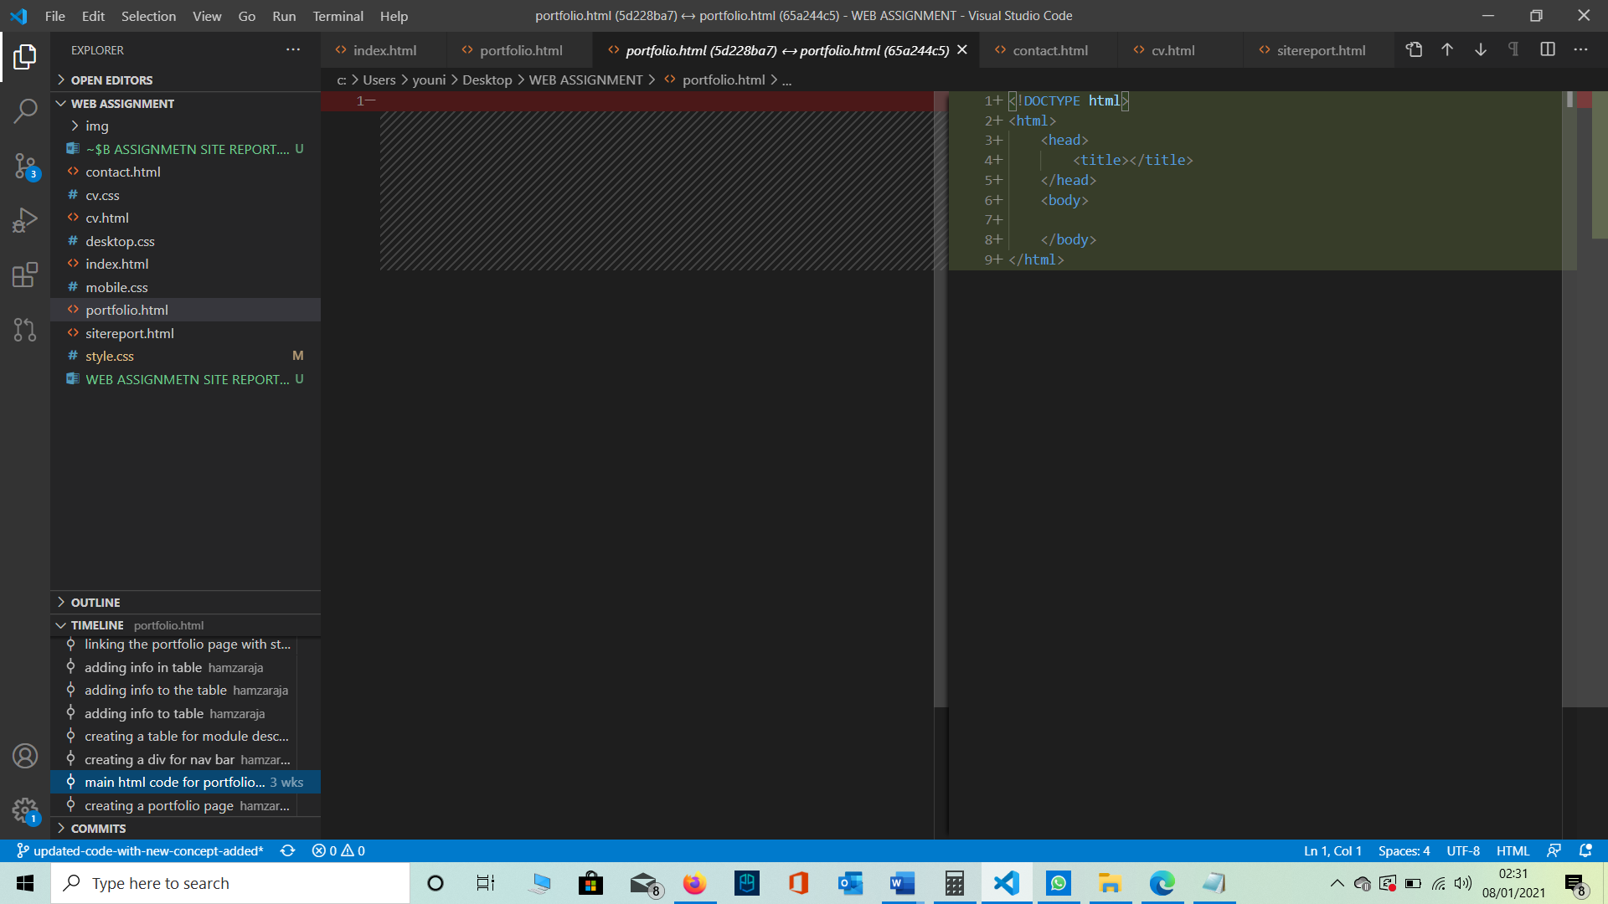

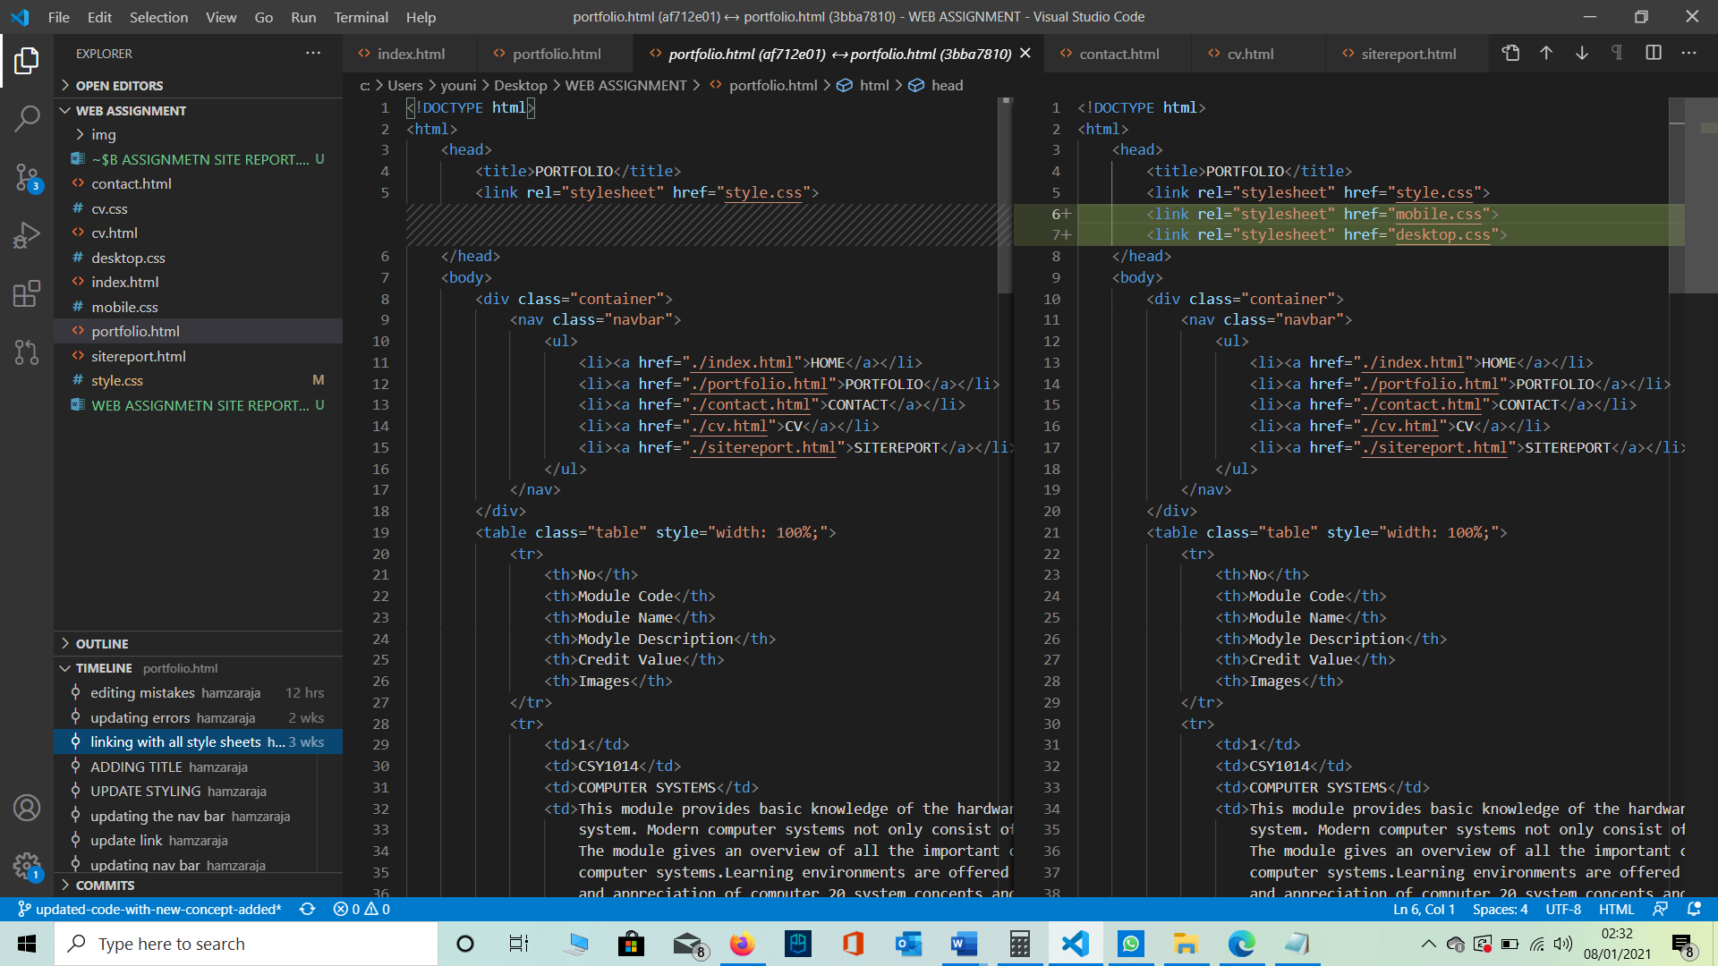

1. **CONTACT.HTML**

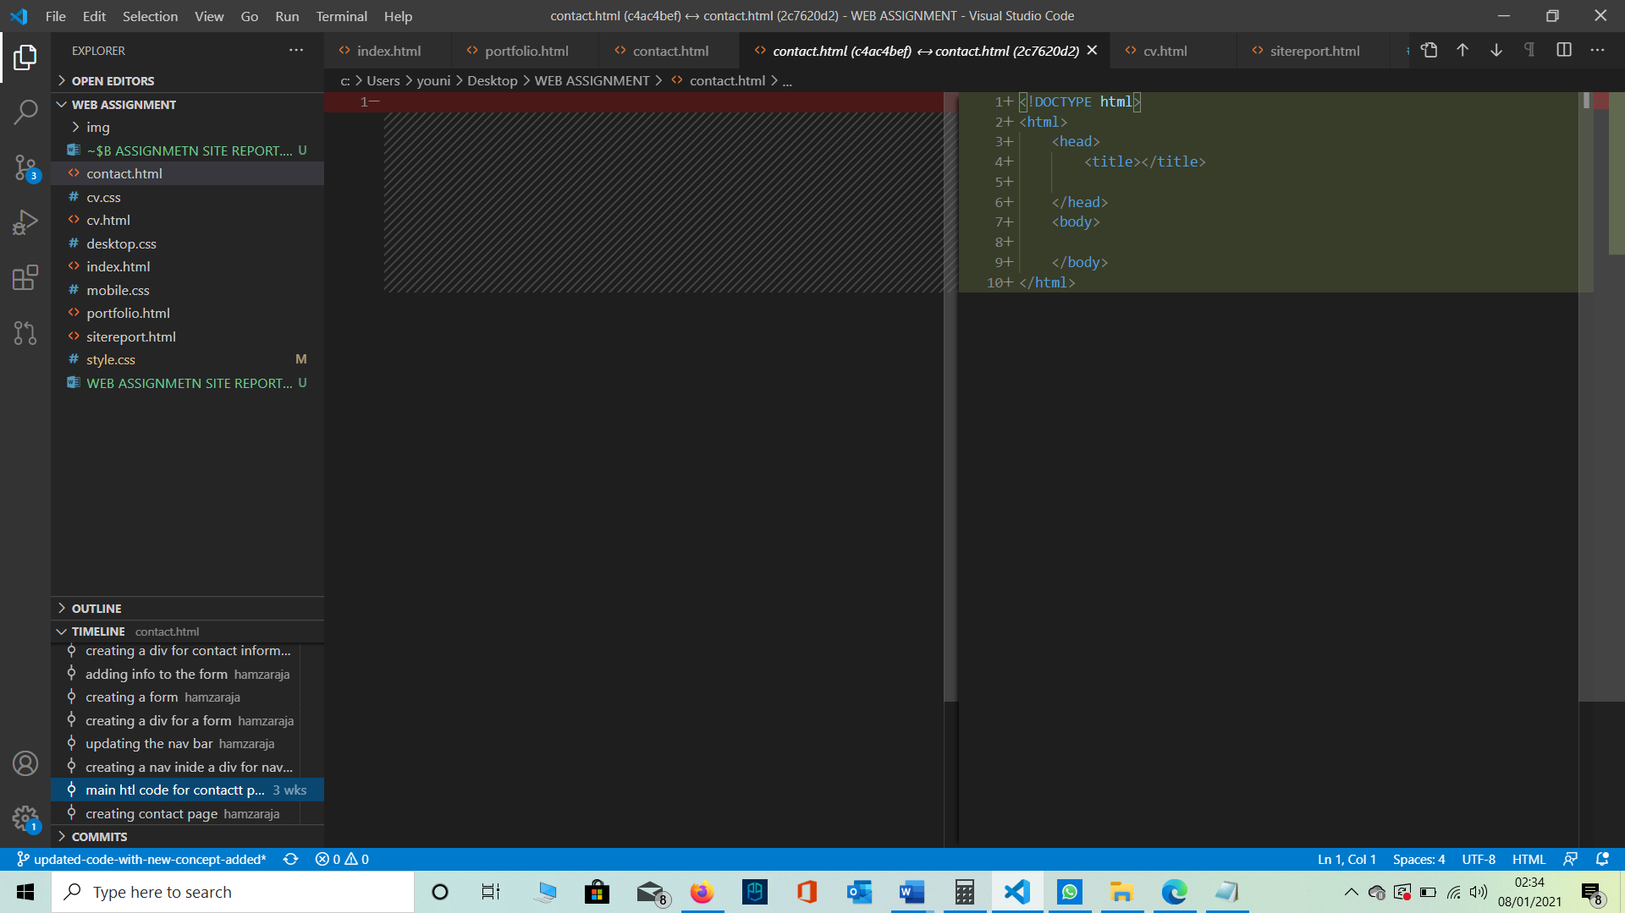

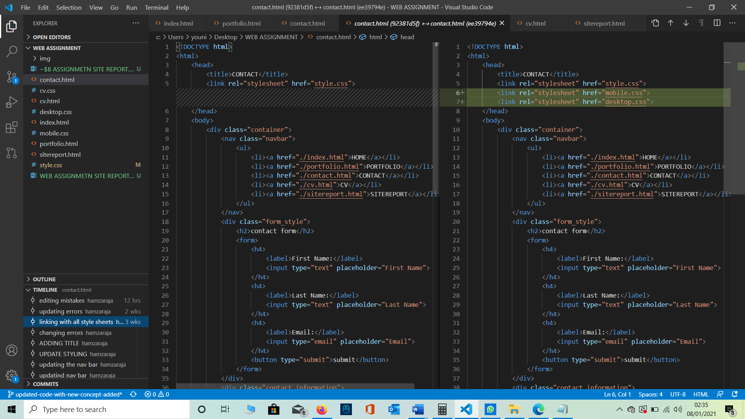

1. **CV.HTML**

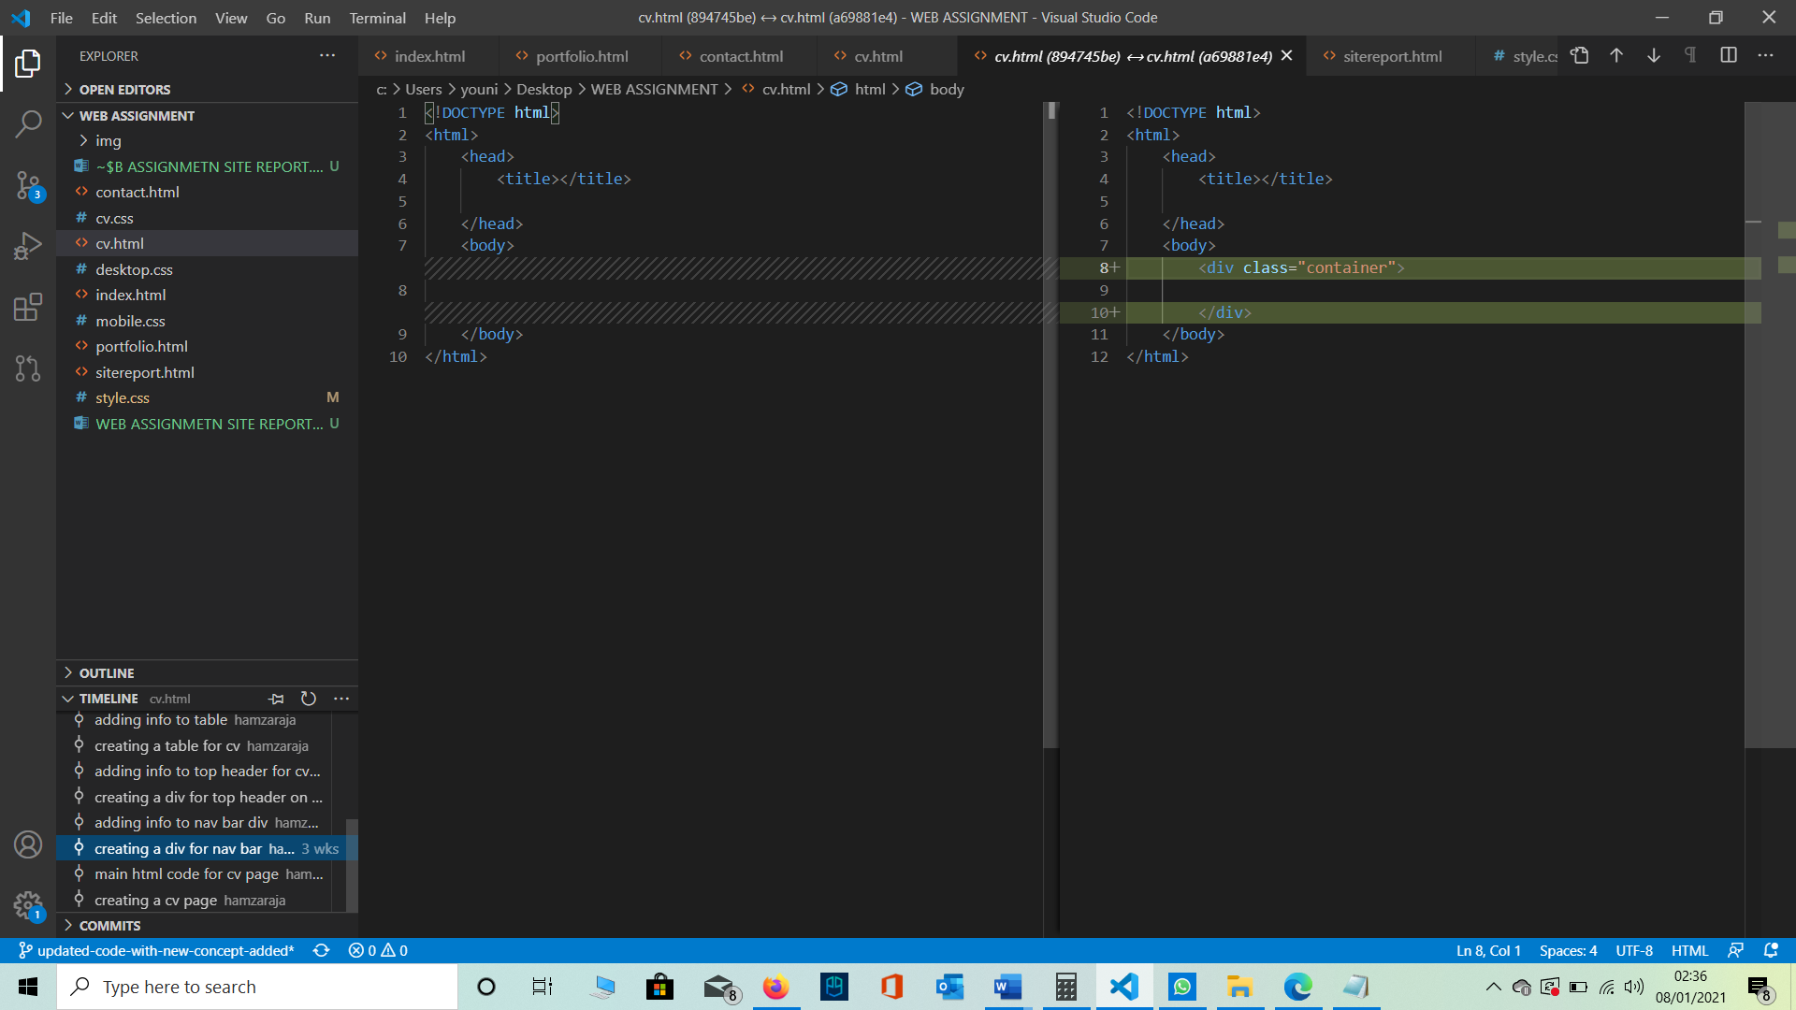

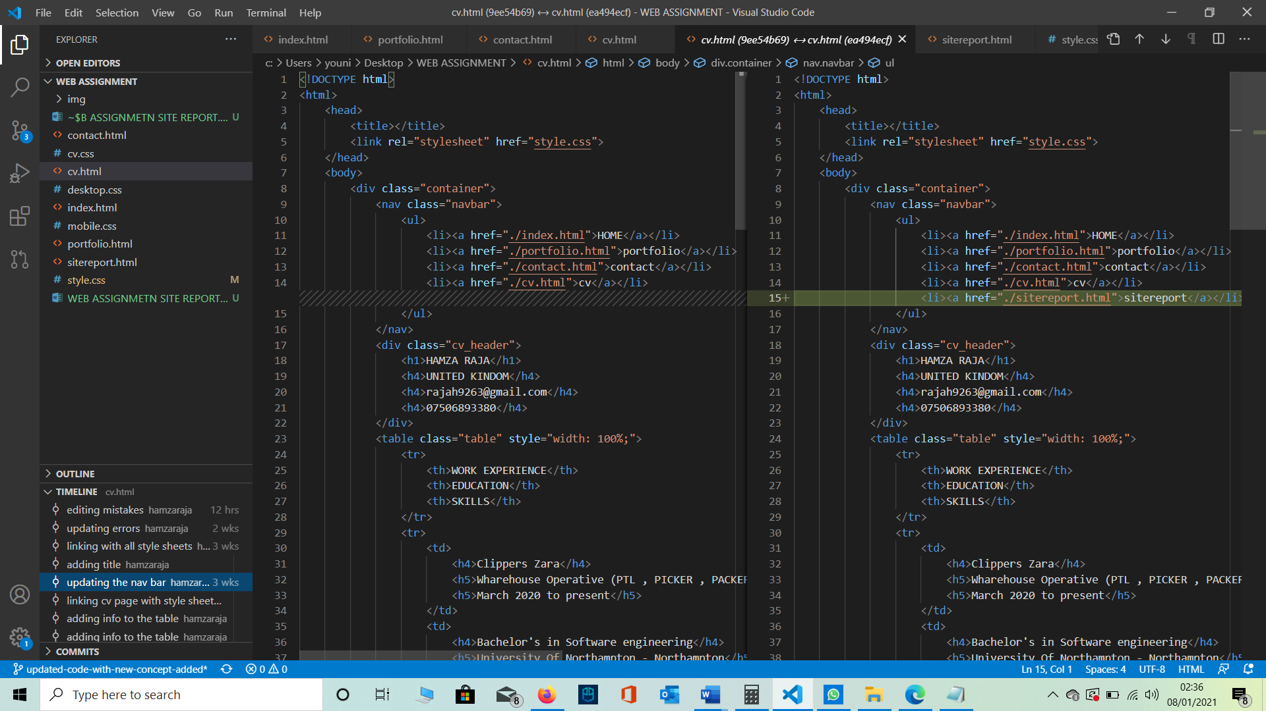

1. **SITEREPORT.HTML**

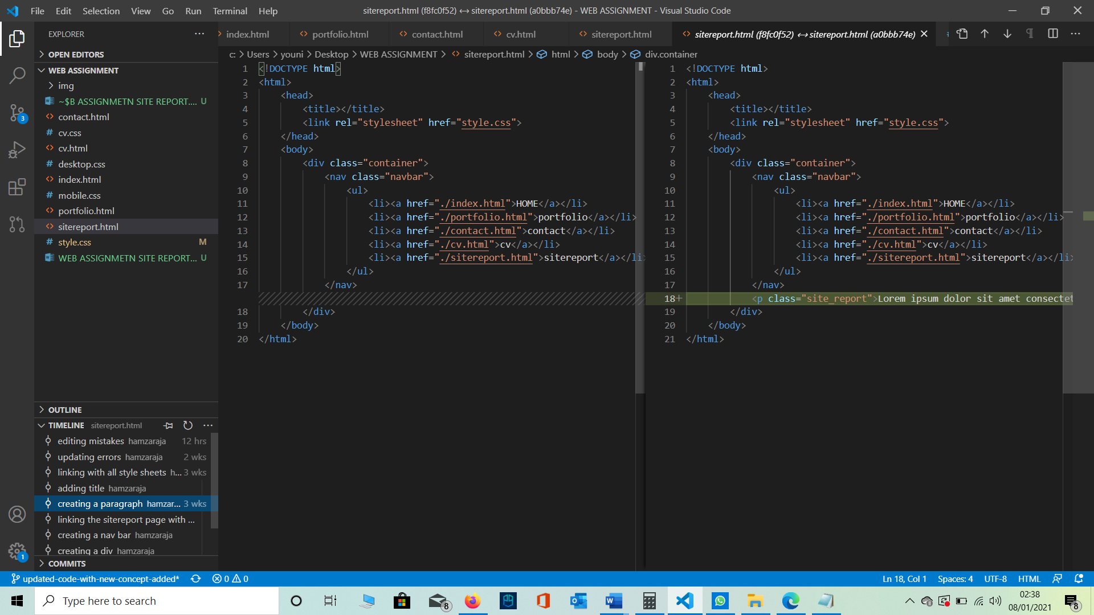

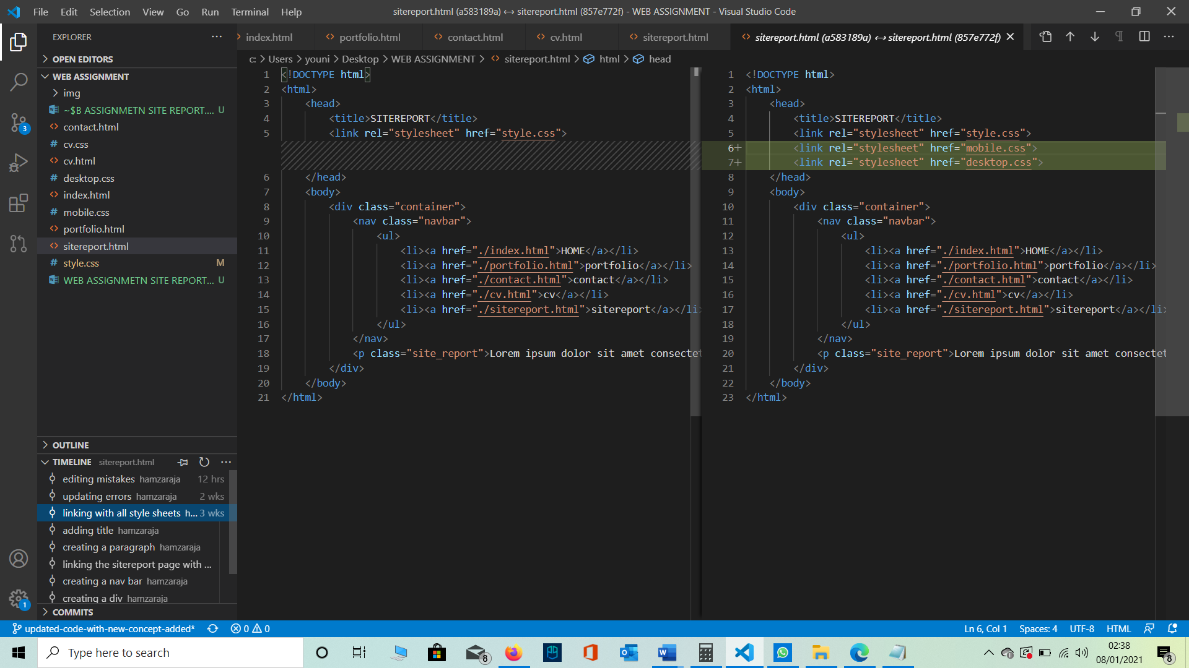

**CHANGES THAT I HAVE MADE IN THE CODE OVER TIME**

**(From 12-11-2020 To 1-7-2021)**

1. **INDEX.HTML**

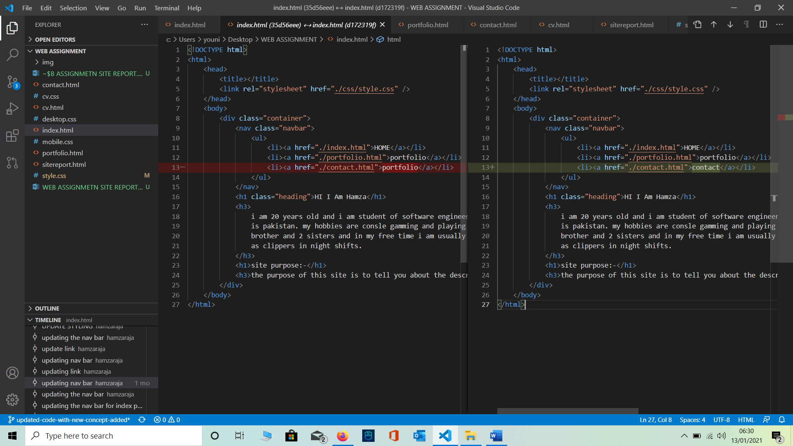

This is a mistake I made I copied the line 12 and paste it in line 13 and save it as it was but when I run the program on the browser there were two portfolio coming on the nav bar so on coming back to the code and analysing it I came to know that here is the mistake on line 12 and 13 that both of them are same and that’s where I changed the portfolio on line 13 to contacts and it became correct .

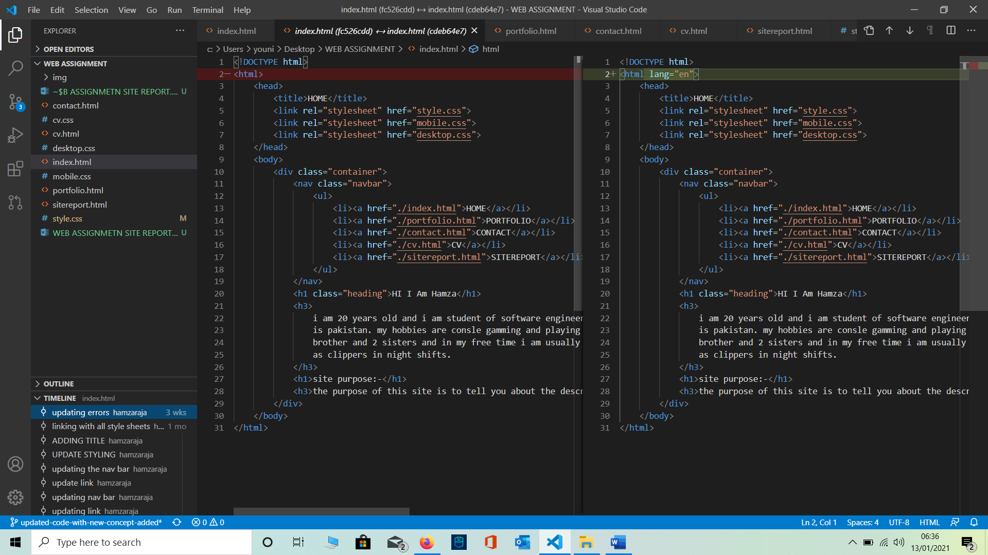

This is a common mistake which I made on all my pages and I didn’t knew what was this mistake until I validated my html pages the validator showed me this error and upon seeking help from my teacher I get to know that this key word has to be added.

1. **CONTACT.HTML**

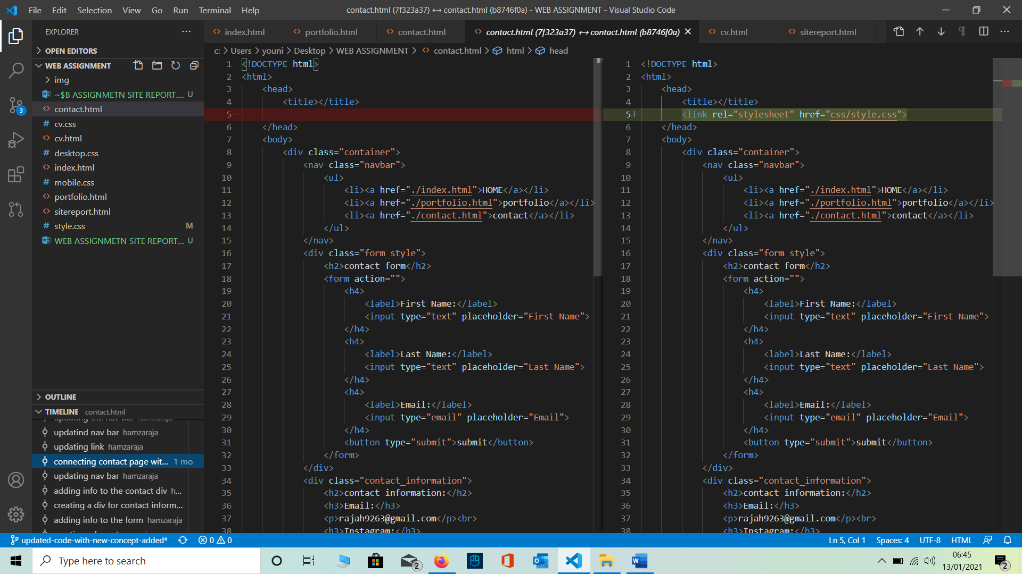

This is a code edition I did after a while when I create my contact page what happened was like I did all of my work on the contact page and all the styling everything was perfect but when I open the contact page on the browser I didn’t had any styling on it at first I didn’t realize that my html page is not connected with my style page I keep on checking the style sheet that weather the commands I used are correct or not then after spending a long time on this when I accidently had a look on the head tag of my html page of the contact that’s when I come to know that I my style sheet is not connected to the html page.

**GIT HISTORY AND COMMITS**

**(From 12-11-2020 To 1-7-2021)**

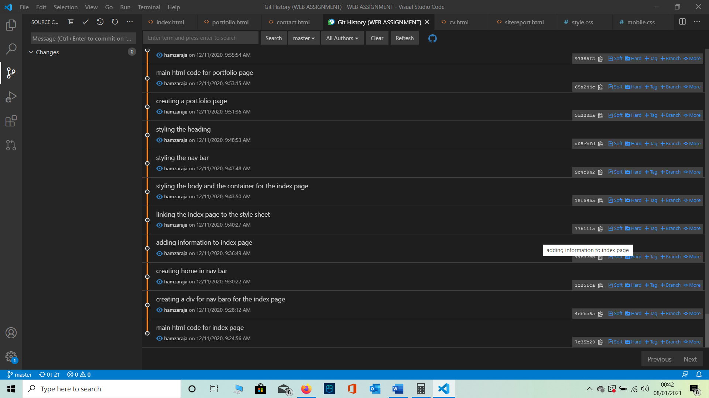

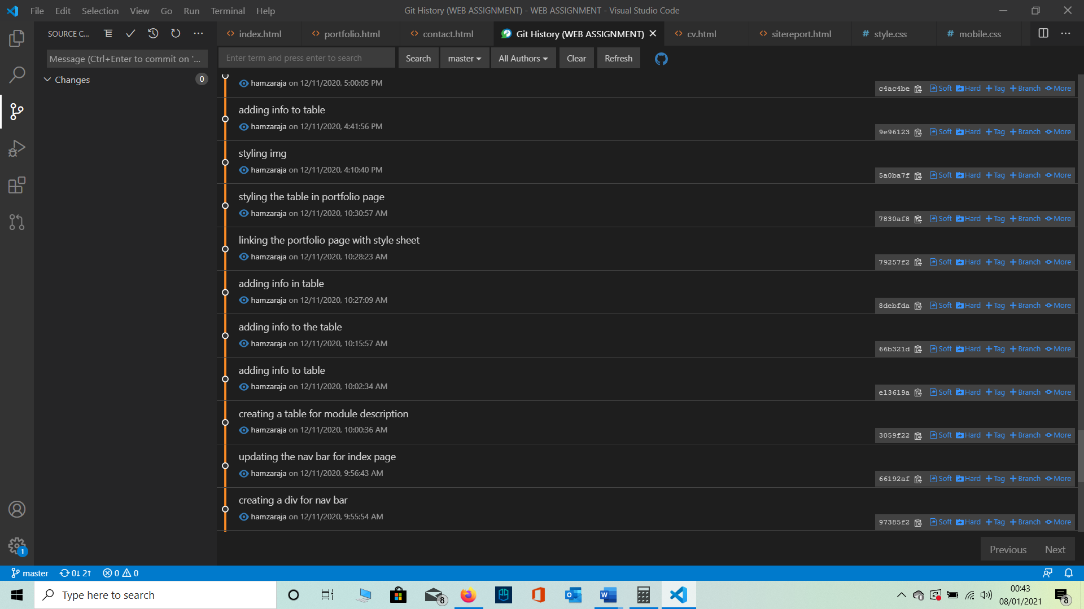

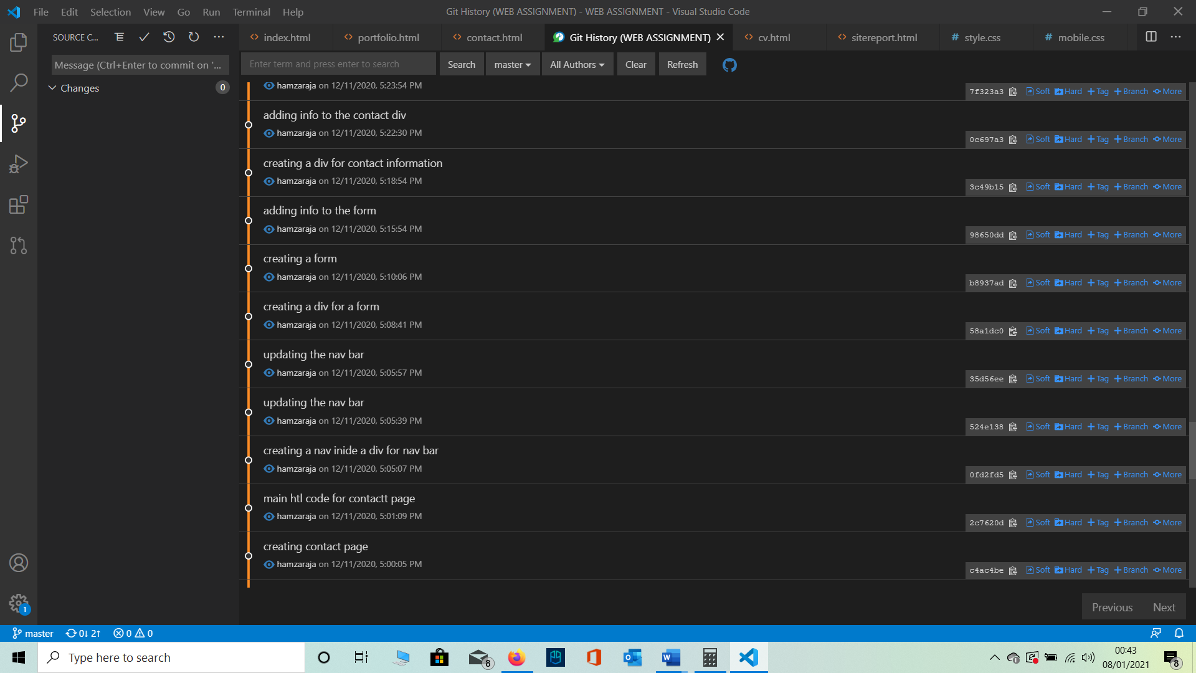

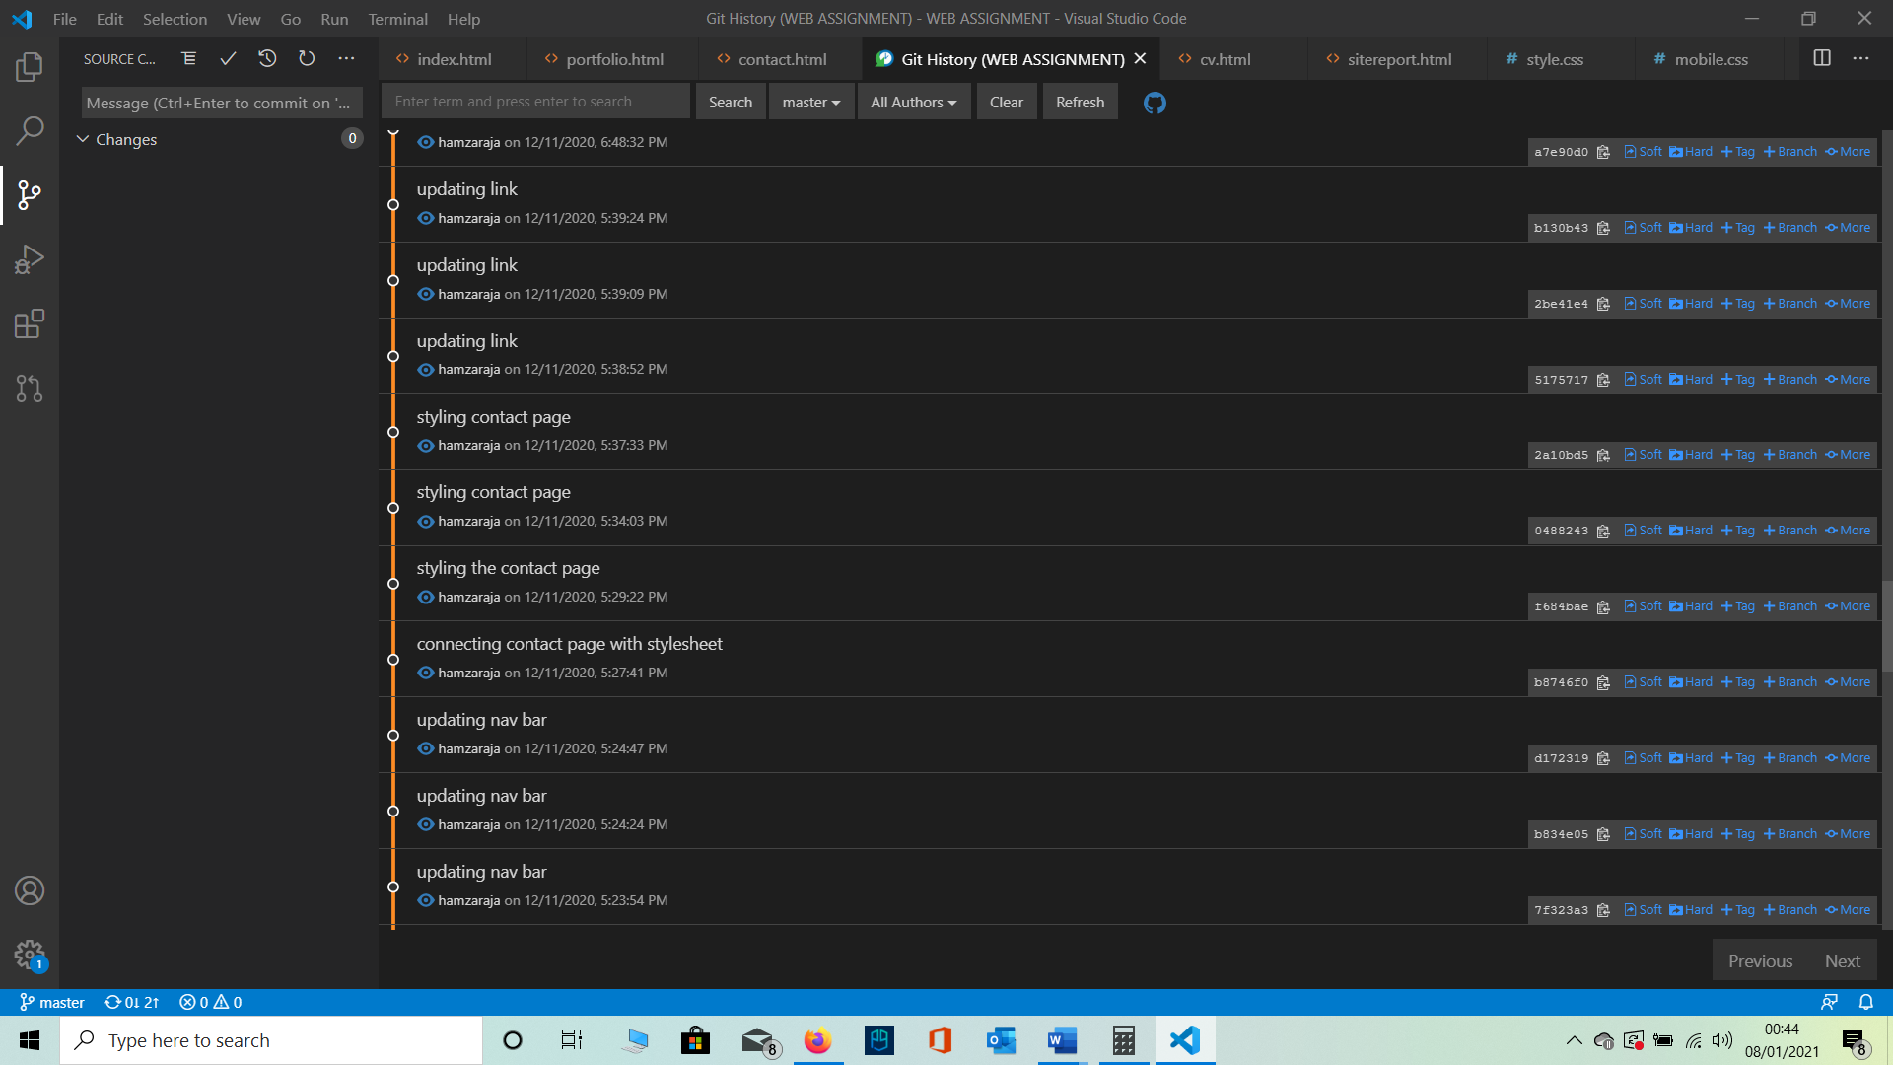

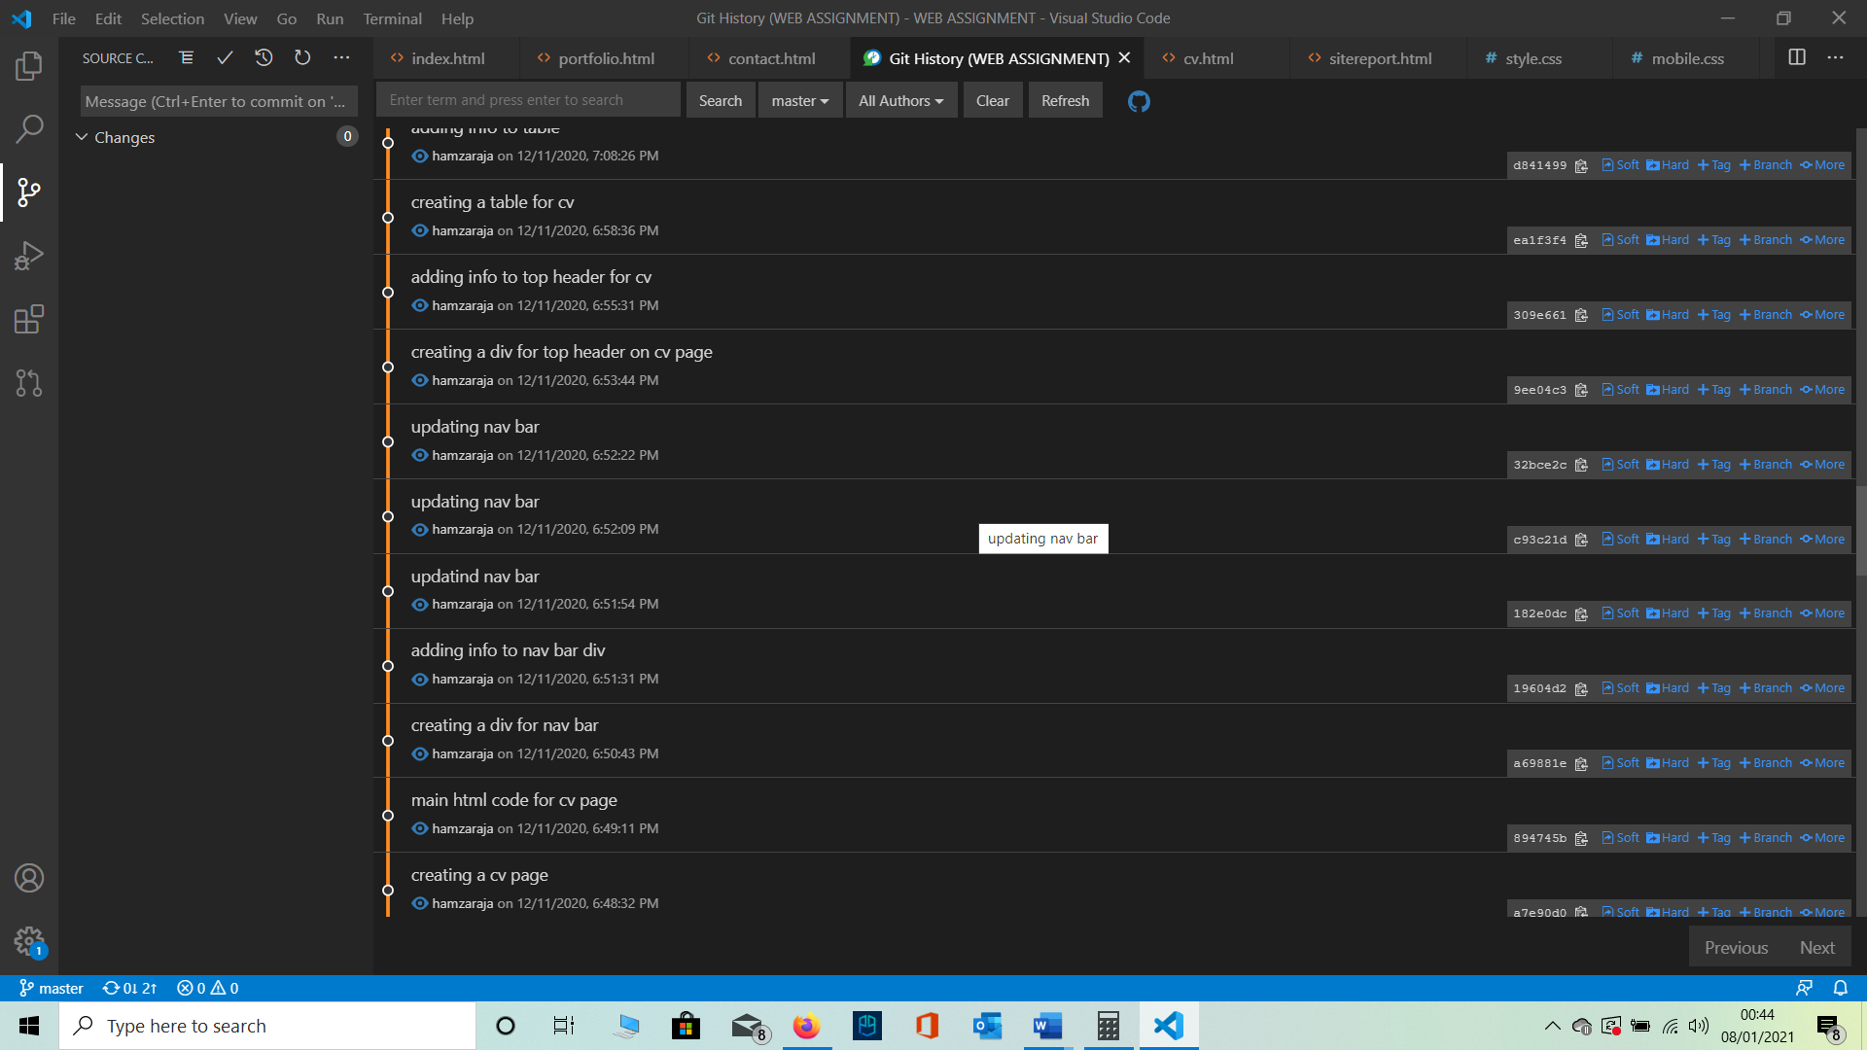

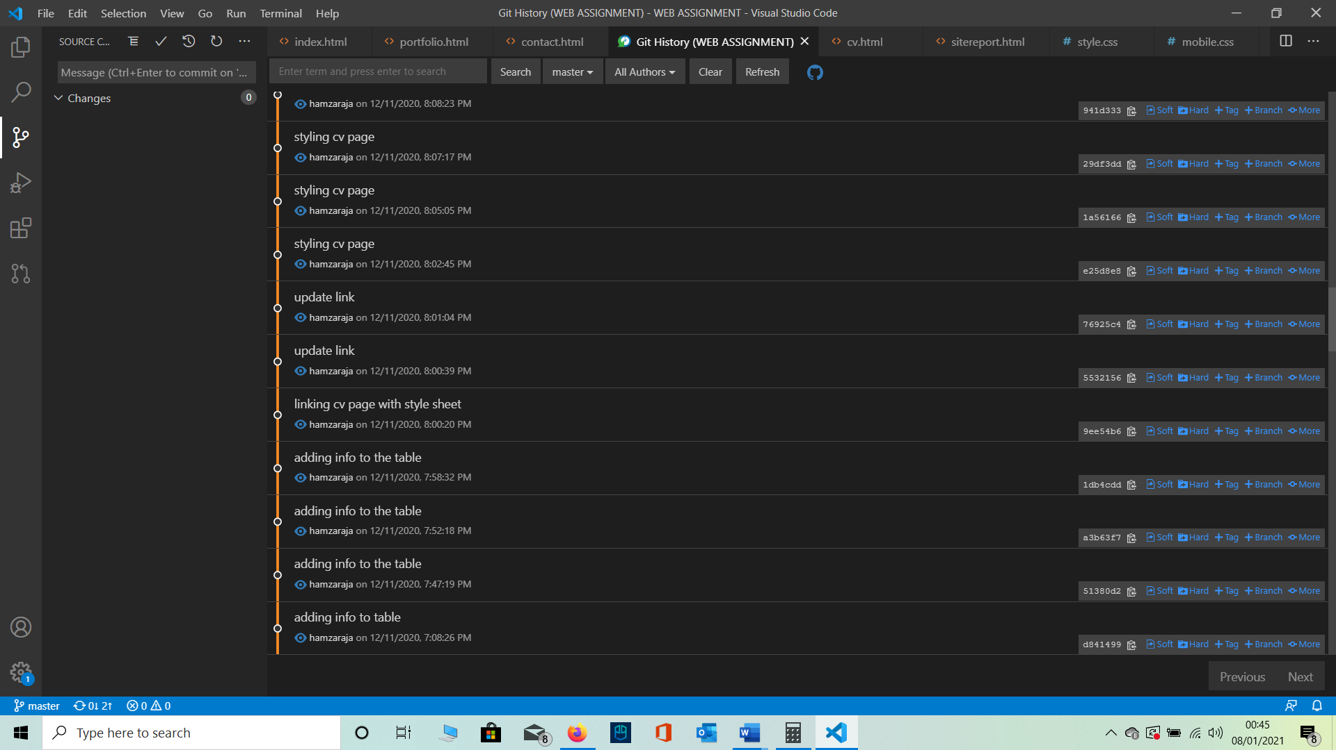

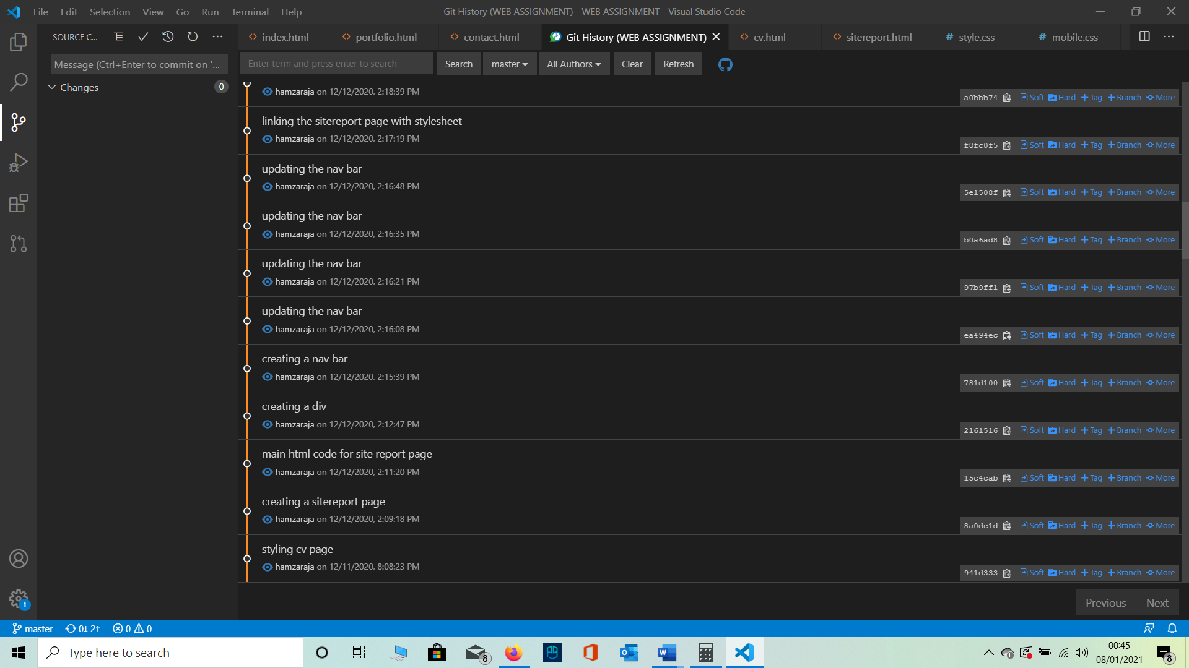

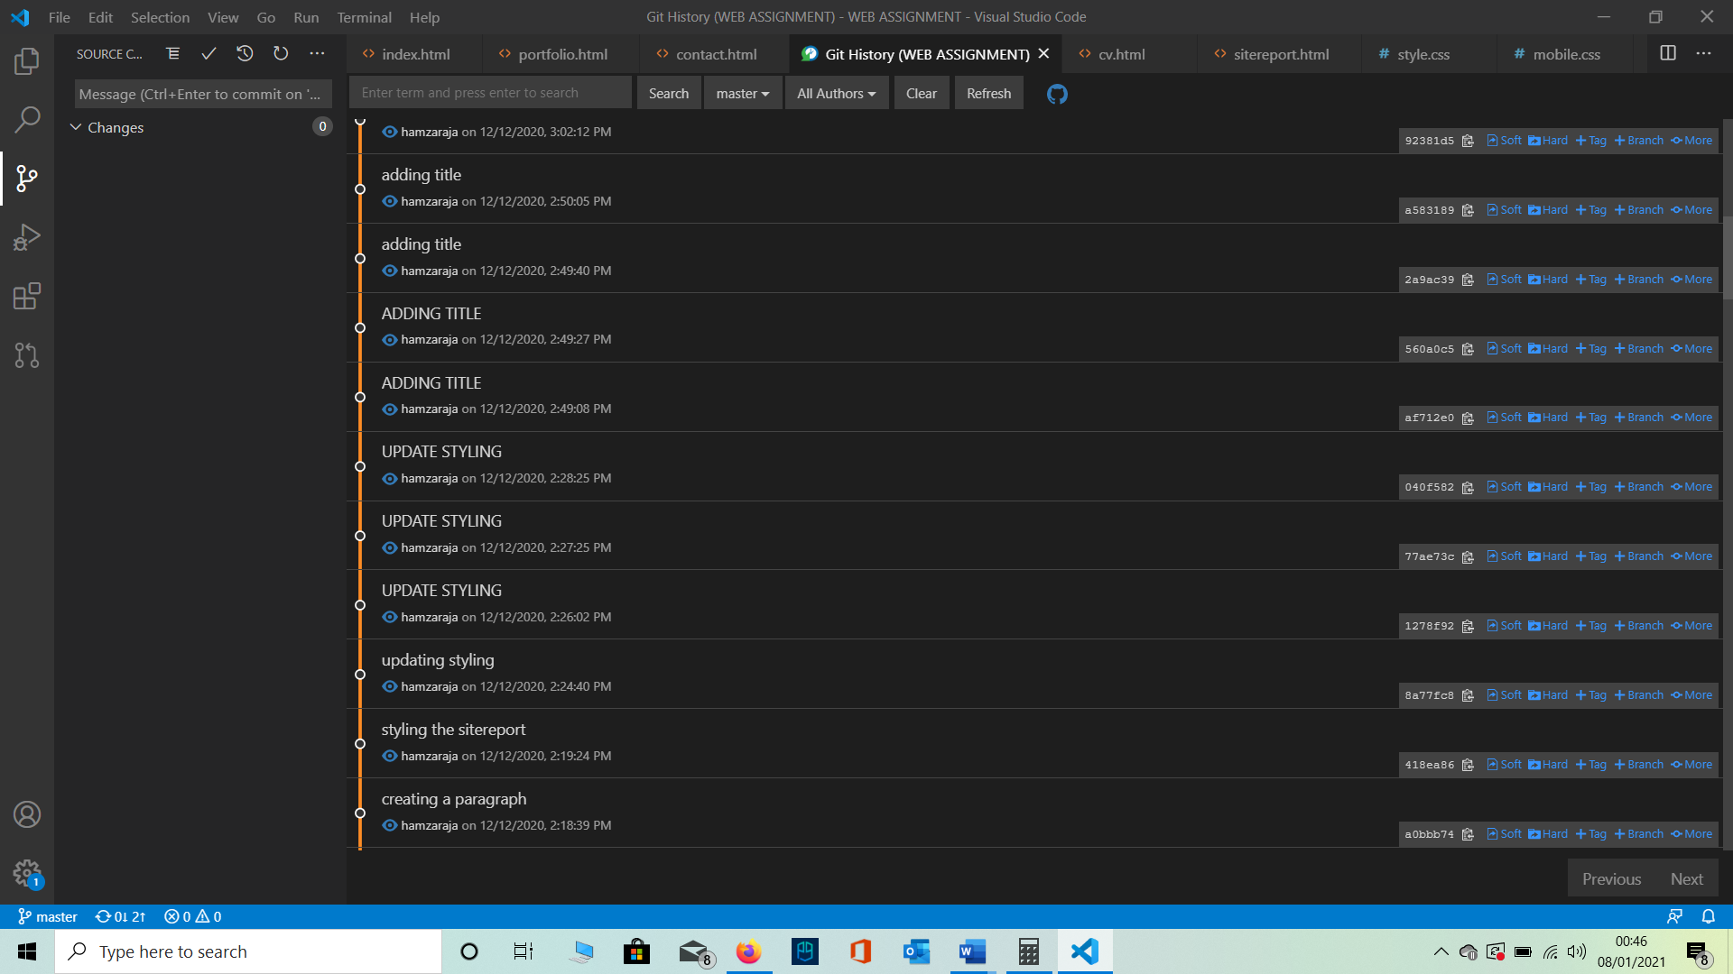

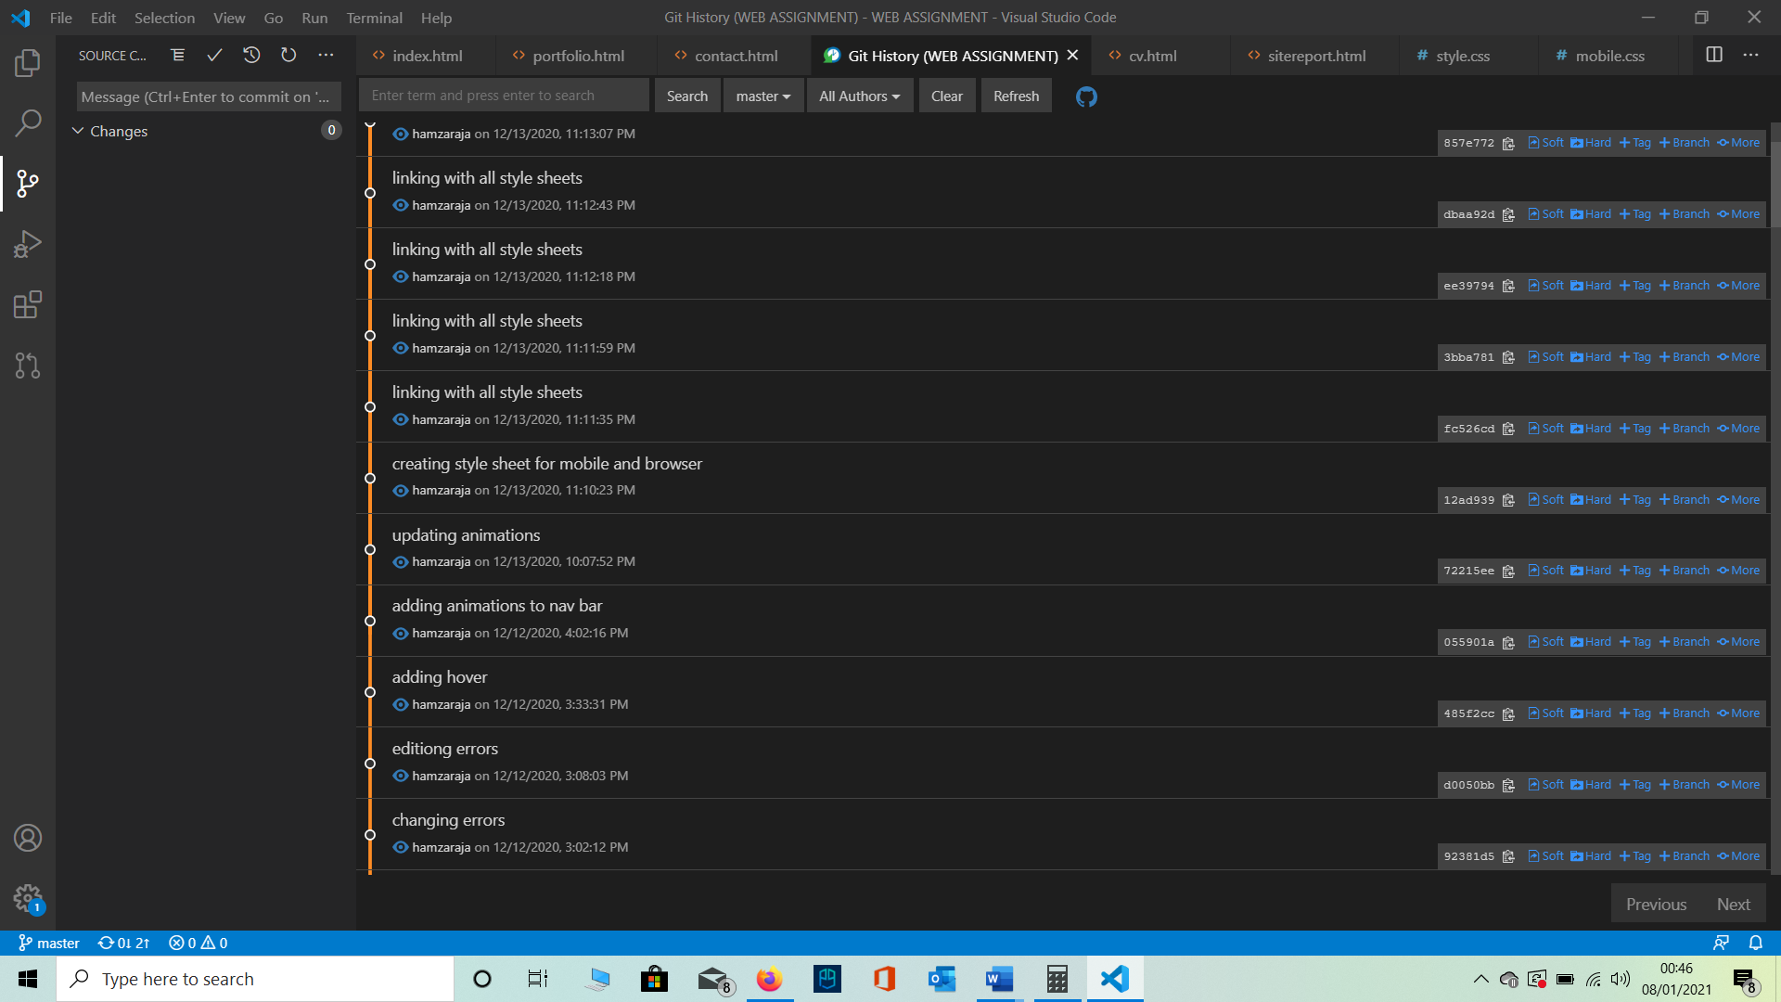

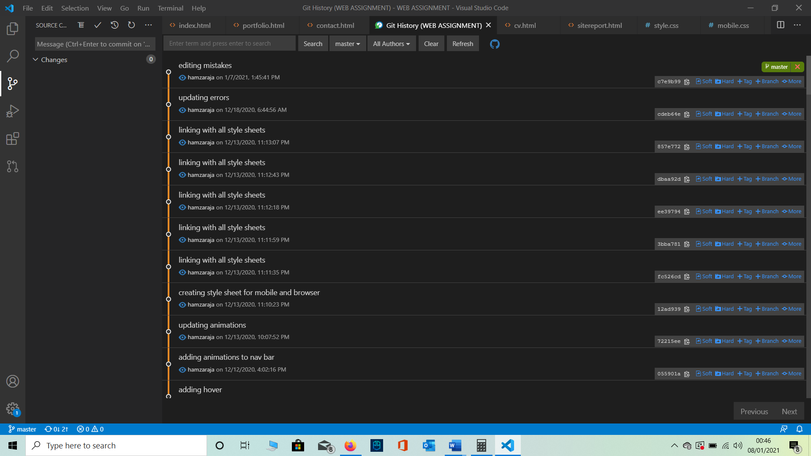

**HTML AND CSS VALIDATATION**

**(1-7-2021)**

**As it can be seen from the below screen shots that all my HTML and CSS pages validate .**

**HTML**

1. INDEX.HTML **VALADATATION**

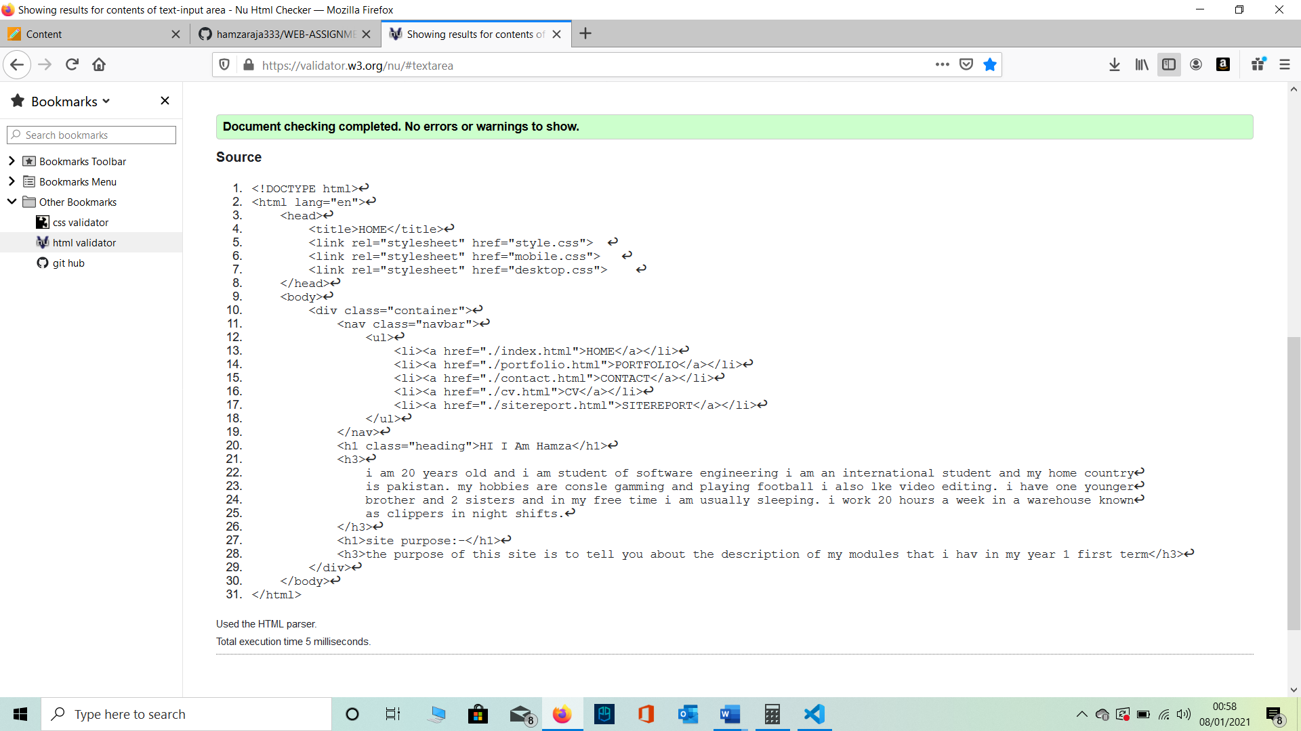

1. 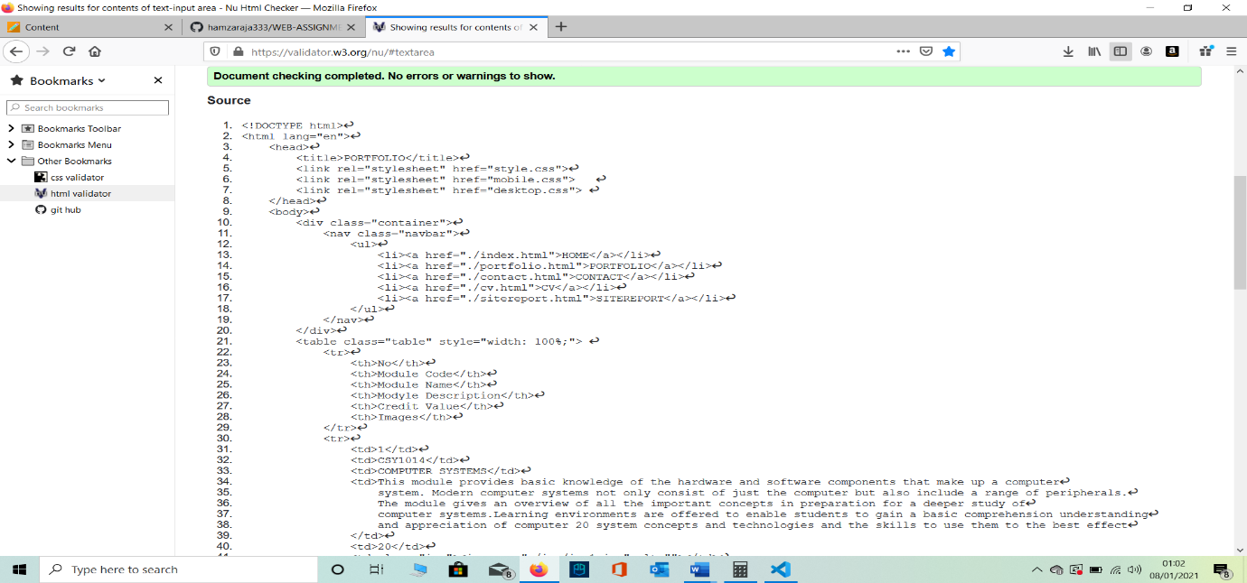PORTFOLIO.HTML **VALADATATION**
2. CONTACT.HTML **VALADATATION**

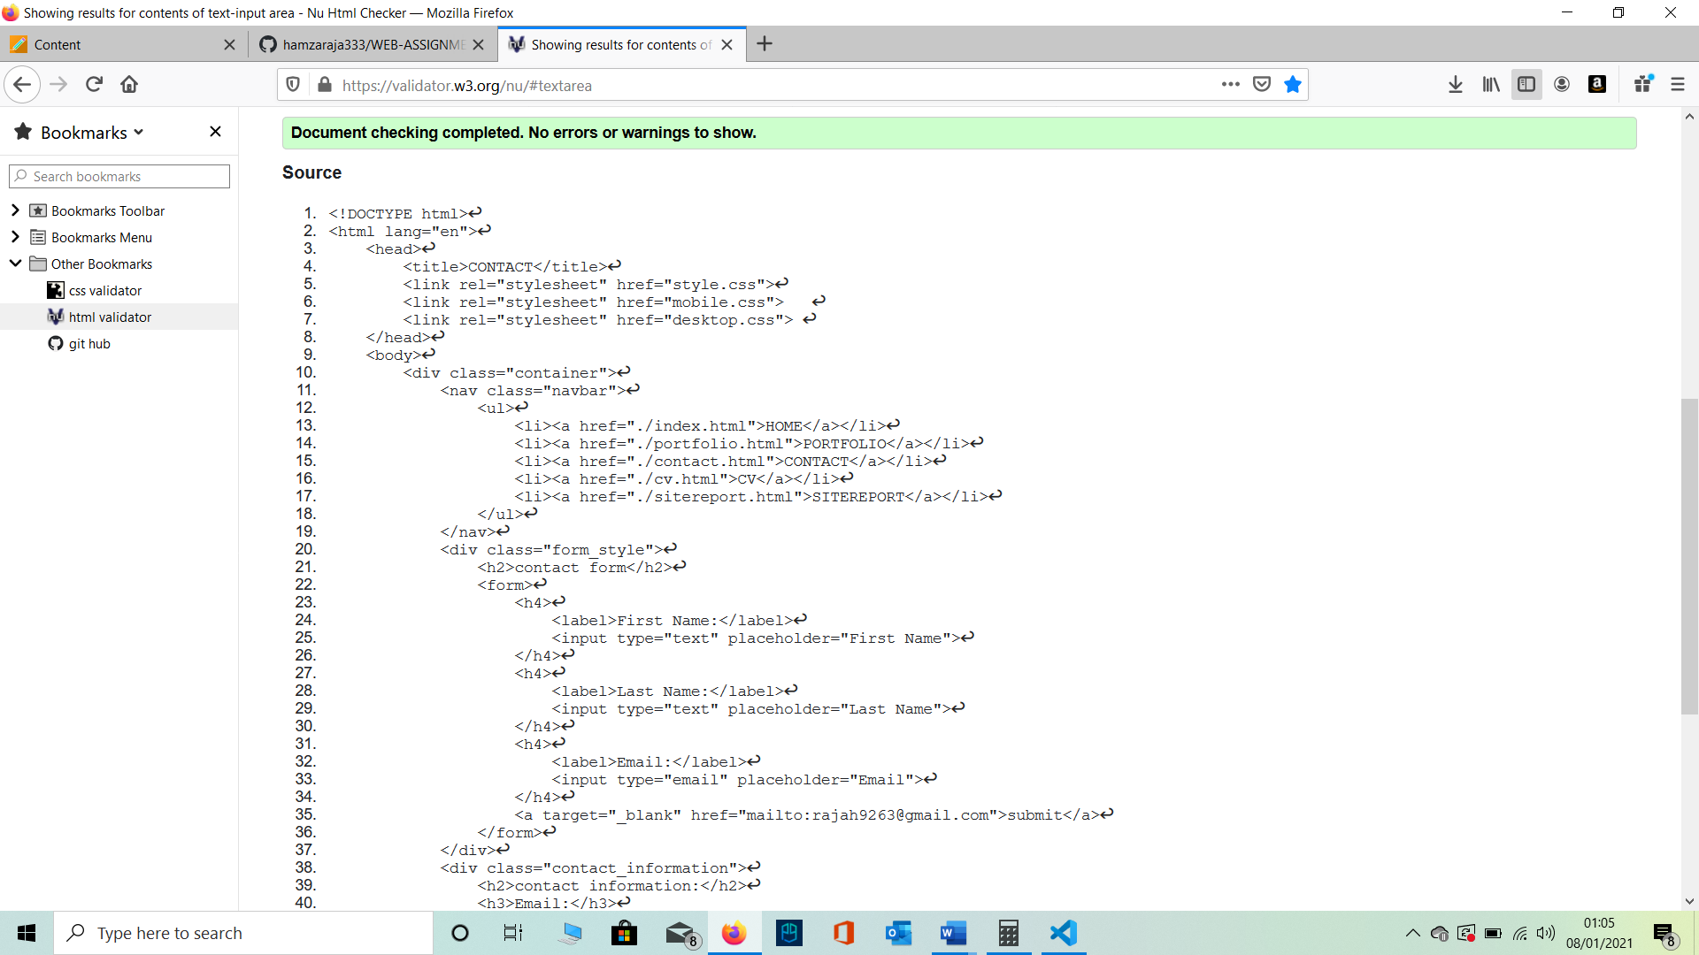

1. CV.HTML **VALADATATION**

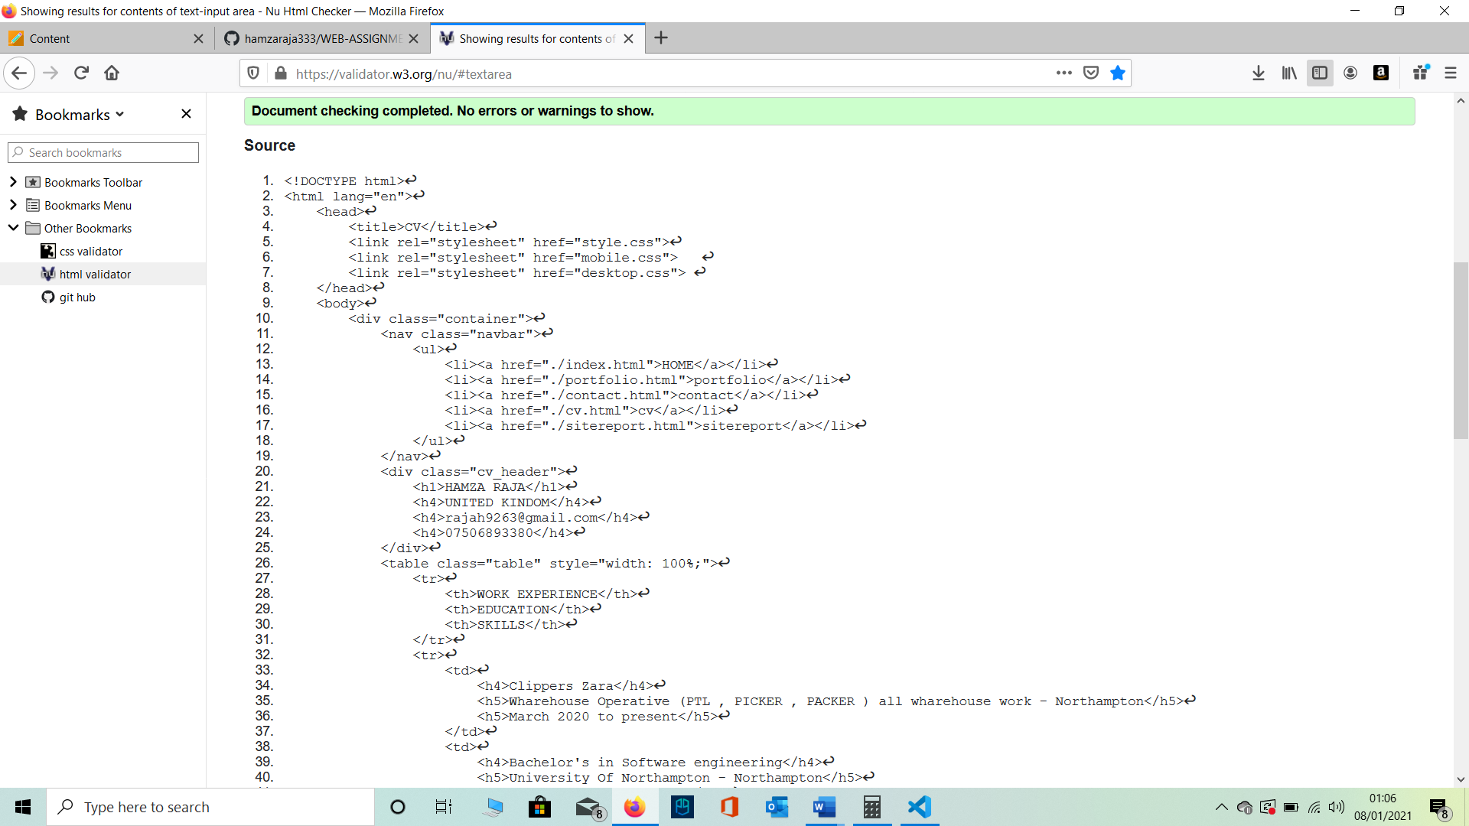

1. SITEREPORT.HTML **VALADATATION**

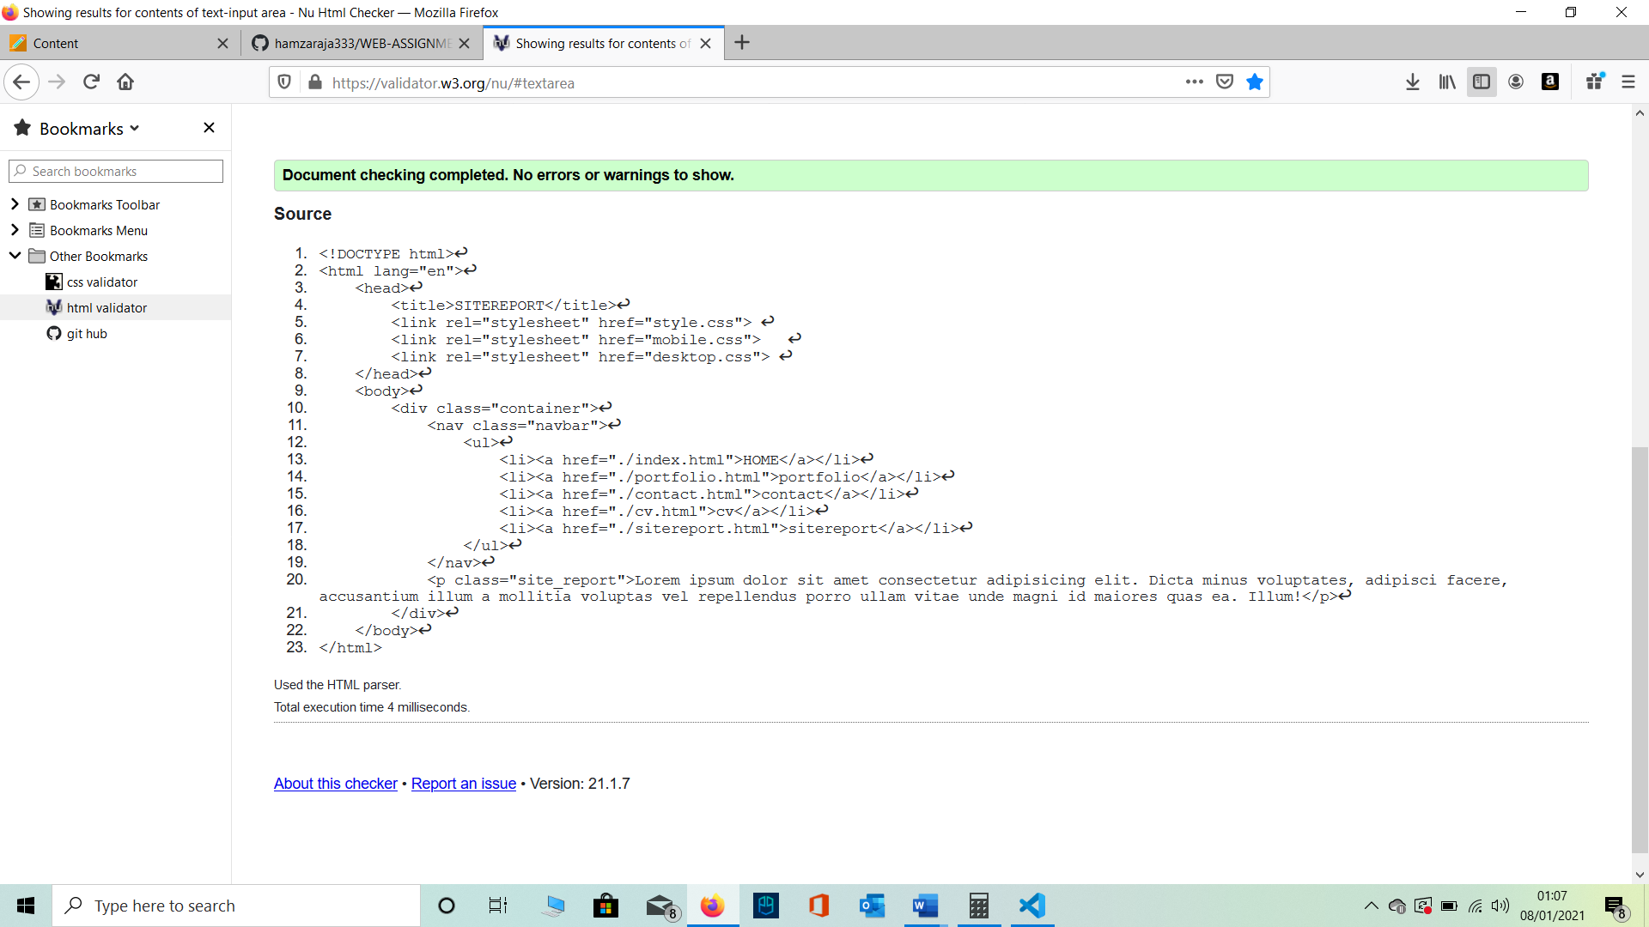

**CSS VALADATATION**

